Sports Club and Society Risk Assessment Record Guidance.
Every Sports Club and Society must have an updated Risk Assessment Record. This is to ensure that all involved in the Club and Society are aware of risks to their wellbeing and can mitigate for accidents occurring. Risk Assessment Records must be updated at least every academic year, however should be amended as and when risks arise that have not previously been identified.
A risk assessment is not about creating huge amounts of paperwork, but rather about identifying sensible measures to control the risks during your activity. You are probably already taking steps to protect your members, but your risk assessment will help you decide whether you have covered all you need to.
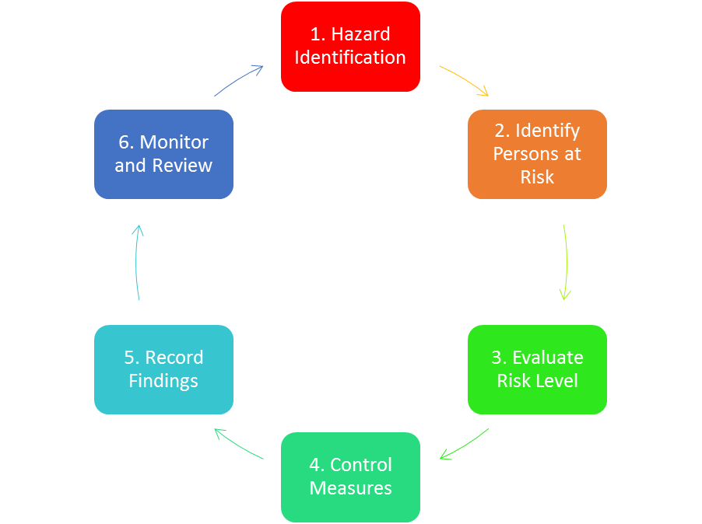
The Risk Assessment Process has 6 stages detailed in the diagram here:-
This document uses these 6 points to help you complete the legally required information for a Risk Assessment Record.
Please watch the On video: Health and safety - online risk assessment presentation provided by Teesside University before completing this document. It can be found here: https://www.tees.ac.uk/depts/hr/audiovisual.cfm
The hazard grid on page 3 is to help you identify the level of risk your club or society undertakes. All activities related to your group need to be documented. Using the grid, looking at Hazard Risk and Probability will give you a risk level (Trivial, Low, Medium, High or Intolerable). If you have identified a Medium or High risk you must write in the Additional Control Measures column what extra your group will do to lower the risk. Intolerable Risk activities will not be permitted to take place.
If you have any questions or would like any help please contact su-activities@tees-su.org.uk.
Sports Club / Society Name:
Enter details of the club/society activities you are risk assessing. Include locations, times, dates, numbers of people, duration and activity descriptions:

Risk Assessor(s) Name (Please detail any experience or qualifications in regards to Health and Safety and undertaking Risk Assessments): | Email Address: | Date:

 | Hazard Effect
Probability | Low  - Superficial injuries  - Minor Cuts and Bruises  - Eye Irritation from dust  - Nuisance and Irritations (e.g. headaches)  - Ill-health leading to temporary minor disability | Medium  - Occupational deafness  - Dermatitis  - Allergy  - Work related upper limb disorders (e.g. repetitive strain)  - Lacerations and open wounds  - Concussion  - Burns  - Serious sprains and strains  - Minor fractures (fingers and toes) | High  - Amputations  - Permanent loss of sight  - Major fractures  - Severe injuries caused by contact with electricity  - Occupational cancer  - Poisonings and gassings  - Fatal injuries  - Other severely life shortening diseases  .
Very Low  So unlikely that probability is close to zero. | Trivial Risk | Trivial Risk | Low Risk
Low  Unlikely but conceivable. | Trivial Risk | Low Risk | Medium Risk
Medium  Could occur several times. | Low Risk | Medium Risk | High Risk
High  Occurs repeatedly and could be expected. | Medium Risk | High Risk | Intolerable Risk

Task and location of activity | Hazards | Cause of Hazard and who impacted? | Current control measures to stop the hazard happening | Hazard Effect (detailed on page 3) | Probability (detailed on page 3) | Additional control measures if medium or high risk | Risk after control measures

